20th Annual AAF-Houston Trailblazer Gala Recap
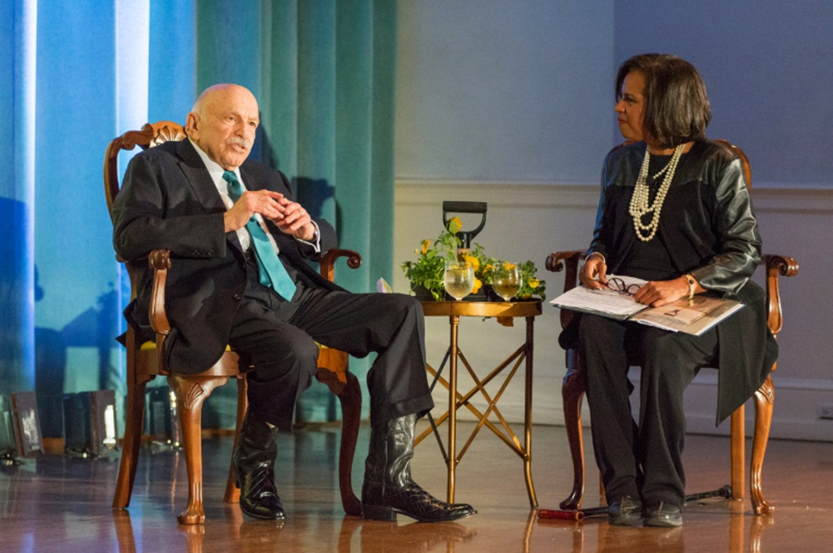

A Night of Celebration with Ed Wulfe
The 20th Annual Trailblazer Gala took place at The Junior League of Houston. It was a night of celebration for a Houston icon, Ed Wulfe, who continues to give so much to the community. For more than 50 years, Ed Wulfe, CEO & Founder of Wulfe & Co., has dedicated his efforts into rebuilding our beloved city, but never failed to volunteer his own time in the community. On this night, we all took a moment of our time to show him gratitude.
Trailblazer Chair Lee Wheat remarked, "The Trailblazer Award recognizes an individual who has made a significant impact on the Houston community both professionally and personally. Ed Wulfe's historic passion for our city and everything Houston is inspiring. His life's story exemplifies an energetic "can-do" spirit that helps distinguish and shape the environment in which we live, work and play."
Melanie Lawson, ABC 13 News anchor and award-winning journalist, served as Master of Ceremonies. She had the pleasure of hosting a one-on-one live interview with Wulfe that captured the audience with laughter and inspiring stories.
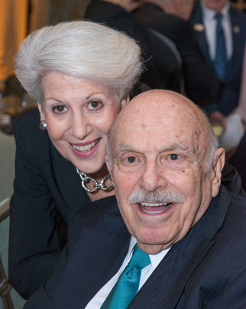
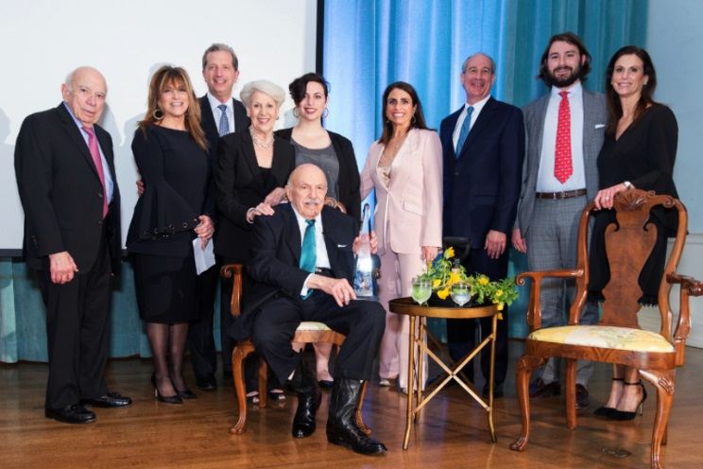
The evening's theme was "Visionary at Work," a term fashioned for Ed Wulfe. After five decades of building, creating and making things happen, he stands among a unique group of development titans who have shaped Houston with his vision and energy. It was an honor to our AAF-Houston members to celebrate Ed Wulfe as the 20th AAF-Houston Trailblazer!

